BRIEFING PAPER

CyberShuttle Enables Mobile High-speed Internet Access
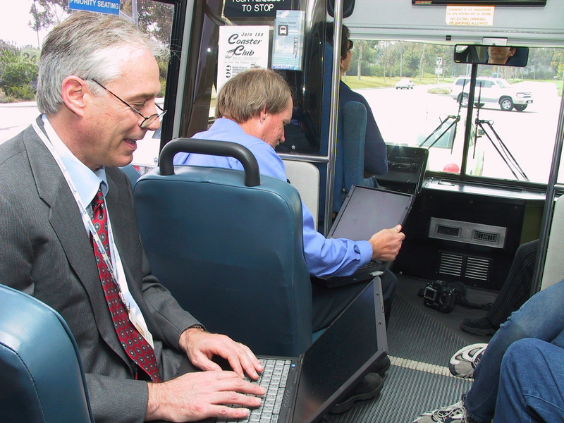
Project: CyberShuttle and CyberShuttle2
PI: Ramesh Rao, Prof, Jacobs School of Engineering; UCSD Division Director, Cal-(IT)²
Division: UCSD
Corporate
Partners: QUALCOMM, Ericsson
Start Date: April 2002

Unveiled on April 1, 2002, the UCSD CyberShuttle is believed to be the world’s first shuttle enabled with wireless, high-speed access to the Internet. Faculty, staff, and students, using laptops and handheld devices enabled with wireless cards, can connect to the Internet at speeds comparable to those at home using DSL or a cable modem while riding between the Sorrento Valley train station and the main UCSD campus. Peak speeds have been measured at 2.4 megabits per second while traveling at 65 miles per hour. This capability is enabled by linking local-area 802.11b wireless technology with QUALCOMM’s 1xEV-DO wide-area network technology using cell sites at EBU 1 on campus and QUALCOMM headquarters in Sorrento Valley.
All laptops, HP Jornada portable digital assistants (PDAs), and PDAs running Pocket PC 2002 using the UCSD campus cyberinfrastructure should work on the shuttle. One must have a wireless card and the appropriate drivers. Visitors may need to set their SSID (network name) to “UCSD” for shuttle wireless services.
This project leverages other development and prototyping through the Always Best Connected project (involving Ericsson) and the San Diego Traffic Report.
The first shuttle equipped with just an outbound link to the Internet is now being extended to a fleet of up to four shuttles with bi-directional capability, which will make it possible to push content to the shuttles. The architecture on each shuttle, designed to accommodate content relevant to shuttle location, time of day, and the interests of the passengers, will feature new capabilities such as audio, video, GPS location awareness, three 17-inch LCD displays, and a ruggedized PC. Anticipated applications include a digital jukebox, GPS mapping to show a shuttle’s location on campus, and the development of content describing campus activities taking place nearby as a shuttle passes. Researchers involved in the project hope the riders will seize the opportunity to develop interactive applications to support user-controllable content via voice, cell phone, or haptics (e.g., hand signals).
“Implementation of the PC changes the previously passive environment to an active one,” says researcher David Hutches, and provides a medium to perform new experiments. “What might you want to do or what content would be meaningful to you if you found yourself on the shuttle for 20 minutes?” he wonders. “That’s the ‘space’ we’re exploring.”
This project is a collaboration among Cal-(IT)², Administrative Computing and Telecommunications, the Jacobs School of Engineering, and the Scripps Institution of Oceanography.
Contact: UCSD Network Operations, (858)534-1857

